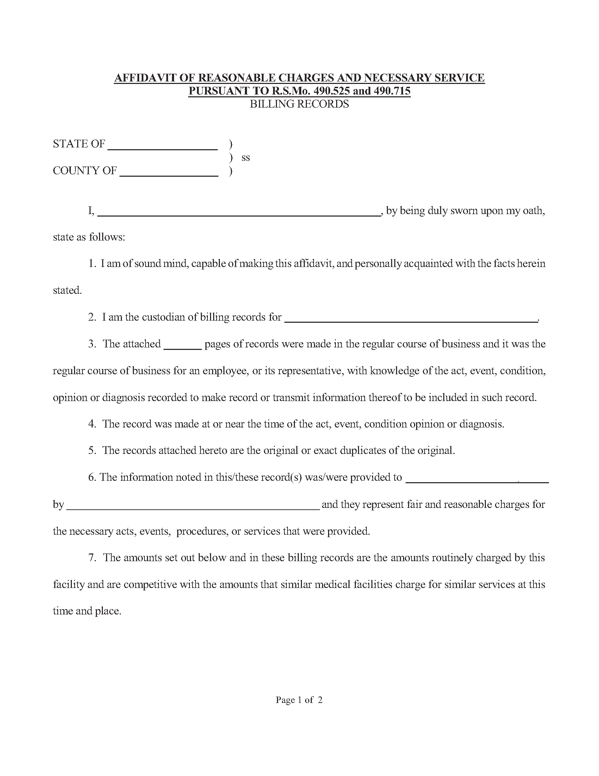
Missouri

University of Michigan Hospital and Health Center
Batman
University of Michigan Hospital and Health Center
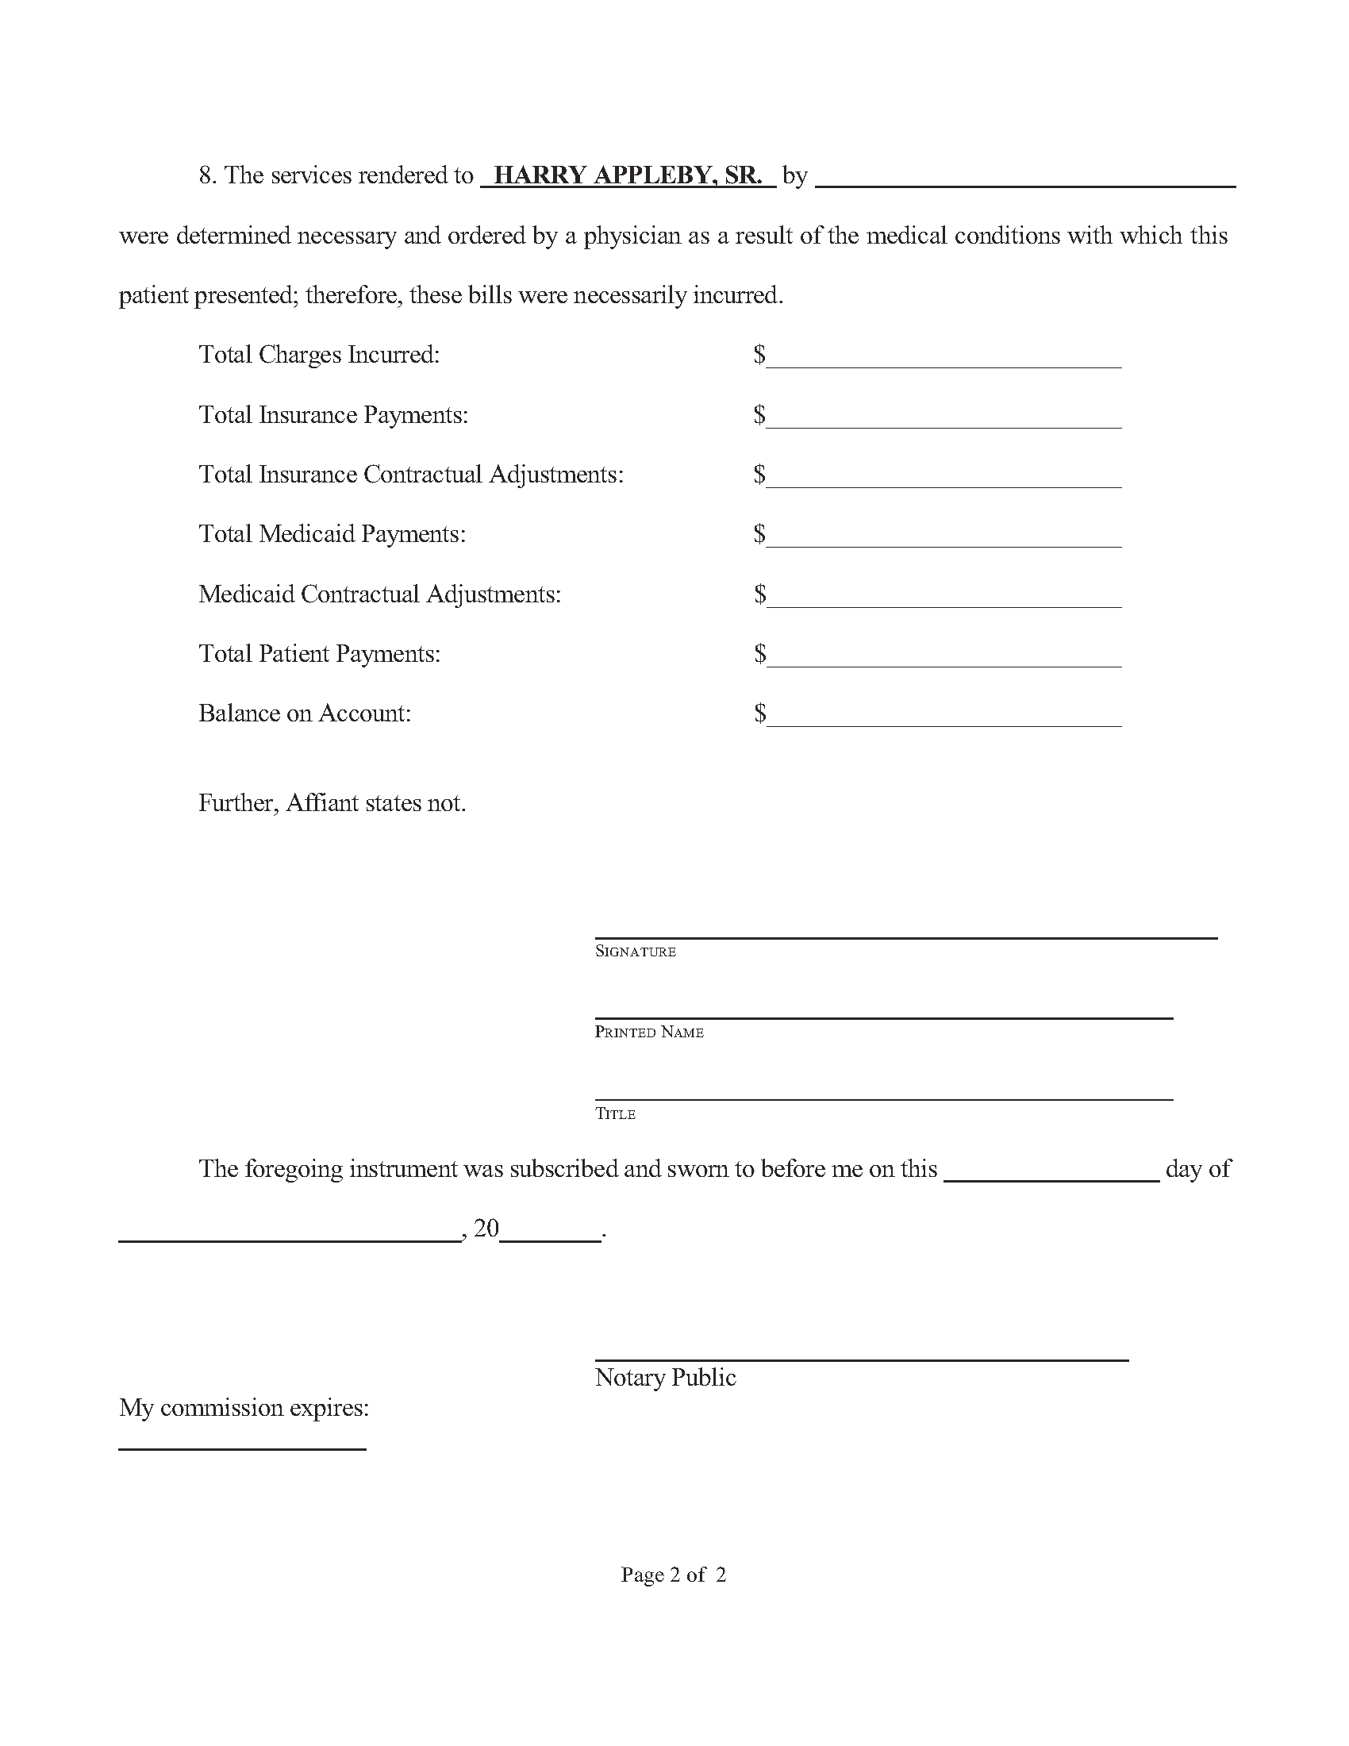
University of Michigan Hospital and Health Center
Batman

